KMTC DMLS LECTURE 3
DATA BASE DEFINITION:
- A collection of information that is organized so that that it can easily be accessed, managed, and updated.
- Database Types can be classified according to content :
- Bibliographic –journals , books and publications
- Full Text – in letters
- Numeric – in numbers
- Images – pictures and videos
Database Management System
- A database management system is a computer software application that interacts with the user, other applications, and the database itself to capture and analyze data.
A general purpose DBMS is designed to allow the
- definition -
- creation,
- querying/ retrieval
- update
- administration of databases
Database Applications
- Databases are used to support internal operations of an organizations and to underpin online interactions with customers and suppliers
- Databases are used to hold administrative information and more specialized data such as engineering data or economic models

Examples of database applications
- Computerized library systems
- Flight reservation system
- Computerized inventory system
- Computerized Hospital management System (e g IQ Care )
- And many content management systems that store websites as collections of web pages in a database.
Database Elements
- The database schema
- Schema objects
- Indexes
- Tables
- Fields and columns
- Records and rows
- Keys
- Relationships
- Data types
Database Schema
- A database schema is the skeleton structure that represents the logical view of the entire database.
- It defines how the data is organized and how the relations among them are associated.
- It formulates all the constraints that are to be applied on the data.

Example of a database schema:
FIELDS
Class
Class ID
Lecturer
LINKK
Room
TABLES
Student
First Name
Last Name
Class ID

Schema Objects
A schema object is an object that resides within a schema. The most typical object found in a database is a table. Other types of objects can reside in a schema, such as indexes, constraints, views, and procedures

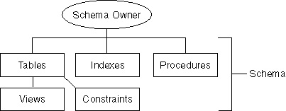
Tables
- A table is the primary unit of physical storage for data in a database.
- When a user accesses the database, a table is usually referenced for the desired data.
- Multiple tables might comprise a database, therefore a relationship might exist between tables.
- Because tables store data, a table requires physical storage on the host computer for the database.

Database Tables and Their Relationship
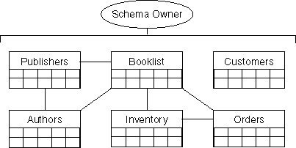

Types of Tables
Tables are used to store the data that the user needs to access. Tables might also have constraints attached to them, which control the data allowed to be entered into the table.
Four types of tables are commonly used:
- Data tables -store most of the data found in a database.
- Join tables -are tables used to create a relationship between two tables that would otherwise be unrelated.
- Subset tables- contain a subset of data from a data table.
- Validation tables- often referred to as code tables, are used to validate data entered into other database tables.

Columns
- A column, or field, is a specific category of information that exists in a table.
- A column is to a table what an attribute is to an entity.
- . A column represents one related part of a table and is the smallest logical structure of storage in a database.
- Each column in a table is assigned a data type. The assigned data type determines what type of values that can populate a column.
- When visualizing a table, a column is a vertical structure in the table that contains values for every row of data associated with a particular column.

Columns Illustrated Row of Data in a Database Table

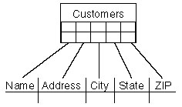
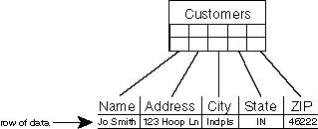
Data Types
- A data type determines the type of data that can be stored in a database column.
Although many data types are available, three of the most commonly used data types are:
- Alphanumeric
- Numeric
- Date and time
Alphanumeric data types
- Alphanumeric data types are used to store characters, numbers, special characters, or nearly any combination.
- If a numeric value is stored in an alphanumeric field, the value is treated as a character, not a number.
- In other words, you should not attempt to perform arithmetic functions on numeric values stored in alphanumeric fields.

Other Data Types
- Numeric data types are used to store only numeric values.
- Date and time data types are used to store date and time values, which widely vary depending on the relational database management system (RDBMS) being used.

Components of a Database system
A database system is composed of four components:
- Data – stored facts or figures
- Hardware: collection of the physical parts of a computer system.
- External Hardware – monitor, key board, mouse, CPU etc
- Internal Hardware – Hard disc drive, motherboard , video card etc
- Software: (system & application) the encoded programs and instructions used to run the system:
System software – Files and programs that makes the computers operating system (OS) eg Windows, Mac OS X, Unix and Linux. BIOS – Basic input /output system
- Application software –a program used for a particular application eg word processor, spreadsheets, presentation, music, camera etc
- Users – a person who uses computers for work, entertainment, business or communication.

xxxxxxxxxxxxxxxxxxxxxxxxxxxxxxxxxxxxxxxxxxxxxxxxxxxxxxxxxxxxxxxxxxxxxxxxxxxxxxxxxxxxxxxxxx

